BEDFORDSHIRE COUNTY FEDERATION

OF WOMEN'S INSTITUTES

Margaret Smart

Memorial Trophy 2023

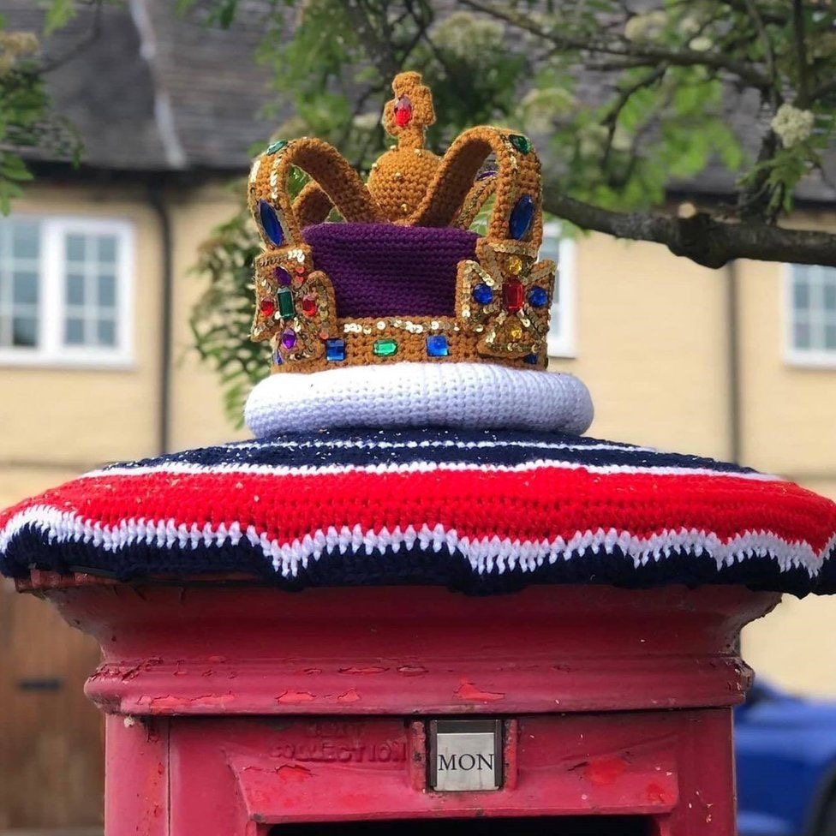

Cookery Craft & Garden Sub-Committee

**CRAFT COMPETITION**

Craft Competition

WI House, 62 Adelaide Square, Bedford, Beds MK40 2RW

Tel: 01234 359538 / Email: fedsec@bedfordshirewis.org.uk

Registered Charity No. 1029278 Registerd Ltd Company No: 0270888

You are invited to submit for judging

***A POST BOX CORONATION TOPPING***

Knitted and or Crochet

Colours of your Choice.

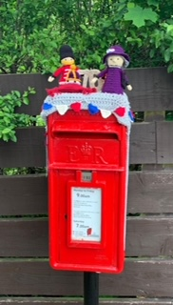

*SCHEDULE*

1. Items must be a pattern of your choice knitted or crochet.

2. Individuals and WIs may submit individual entries or up to 3 members helping. The cost is £5 per entry.

3. Completed application forms, accompanied by the £5 per item entry fee, must be received by WI House no later than Friday 10th March 2023

.

4. Competition entries must be delivered to WI House during office hours, week commencing 10th April 2023.

5. The judges’ decision is final. No correspondence regarding judging will be entered.

6. Submitted entries will be on display at THE ANNUAL COUNCIL MEETING ON 24TH APRIL 2023.When the Margaret Smart Trophy will also be presented.

7. Submitted entries can be collected from WI House week commencing 1st May 2023.

**N.B. By submitting your entry to this competition, you are agreeing to the possibility of it being used for any future BCFWI publications and promotional events.**