BCFWI Membership Advisory Committee

RESOLUTION SELECTION MEETING

Gravenhurst Village Hall, High Street, Gravenhurst, MK45 4HY

Tuesday 29th November 2022 at 7.30pm
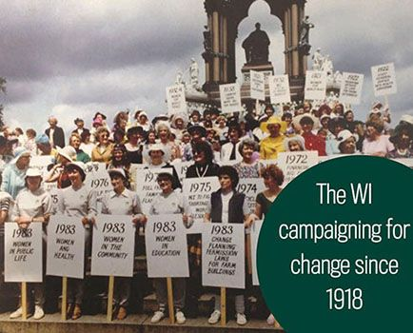
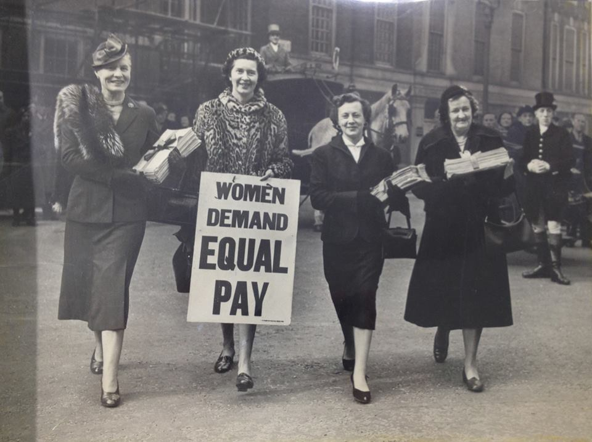
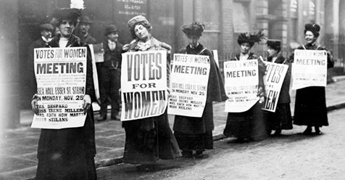

Come along and learn more about the Resolution topics for this year.

You will be given the opportunity to discuss the proposed resolutions
with fellow members and learn more about the resolutions and resolution process.

Towards the end of the year members will vote within their WIs on which resolution
they feel should go forward for discussion at the 2023 AM in Cardiff.

The WI has a strong history of campaigning, at the forefront of many issues affecting members and society alike and we hope that as many WIs as possible will be able to send representatives to this meeting in order to feed important information back to their WIs and members.

Tea/Coffee and biscuits will be provided – WI Members only please

………………………………………………………………………………………………………..

BCFWI - MEMBERS ADVISORY COMMITTEE

RESOLUTION SELECTION MEETING

Gravenhurst Village Hall, High Street, Gravenhurst, MK45 4HY

Tuesday 29th November 2022 at 7.30pm

Cost: £3.00 each

……………………………………………..…WI wishes to book ……….…. places for the above.
Total amount to be invoiced £…………
Name of contact: ……………………………………………………………………….….

Email address: ……………………….………… Telephone No. ………………..…………….

Please return completed form to WI House, 62 Adelaide Square, Bedford MK40 2RW
TICKETS WILL BE ALLOCATED ON A FIRST COME FIRST SERVED BASIS
No Refunds will be made once the booking has been received
Beds CFWI is a registered charity – No: 1029278 and a registered Ltd Company in Wales No: 02708888

Please list name and contact numbers of all attendees below
Applications will not be processed unless all information is completed in full.
THIS INFORMATION IS ESSENTIAL IN CASE WE NEED TO CONTACT THOSE ATTENDING.

NAME |  | MOBILE PHONE NO | Email address

